Note: Since this is a type of math subject. Only theoretical questions are being solved. Because its hard to solve math using keyboards.

2019 Fall

1 b) What is strongly connected graph? ……
Ans: Strongly connected graph is a graph where every vertex is reachable from every other vertex.
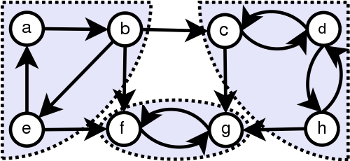

______________________________________________________________________________________________________________________________

2 b) Define the terms in graph theory: Hamiltonian circuit, Euler circuit and Isomorphism with suitable examples.
Ans:

i) A Hamiltonian circuit is a circuit that visits every vertex once with no repeats. Being a circuit, it must start and end at the same vertex.
Note that the circuit only has to visit every vertex once; it does not need to use every edge.
There are several other Hamiltonian circuits possible on this graph. One is ABFGCDHMLKJEA.
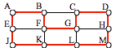

ii) An Euler circuit is a circuit that uses every edge in a graph with no repeats. Being a circuit, it must start and end at the same vertex.
The graph below has several possible Euler circuits. Here’s a couple, starting and ending at vertex A: ADEACEFCBA and AECABCFEDA. The second is shown in arrows.
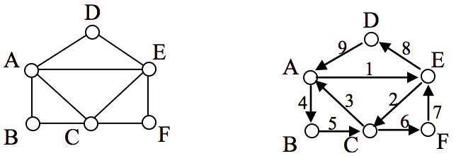

iii) A graph can exist in different forms having the same number of vertices, edges, and also the same edge connectivity. Such graphs are called isomorphic graphs.

In the graph G3, vertex ‘w’ has only degree 3, whereas all the other graph vertices has degree 2. Hence G3 not isomorphic to G1 or G2.
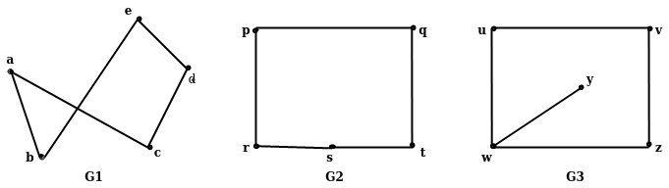
In other hand, G1 and G2 are isomorphic graph.

4 a) Define proposal logic. ….

5 a) What do you mean by mathematical induction? …….

7. Write short notes on any two:

a) Nested Quantifier

b) Universal and Existential quantities
c) “A proof by contraposition”

______________________________________________________________________________________________________________________________

2018 Spring

1 a) Define the term graph, degree of vertex, path, circuit, cycle, adjacency matrix and incidence matrix.
1 b) What is Hamiltonian Cycle? Prove that “A connected graph Q is Eulerian if and only if each vertex has an even degree.”

2 a) Use Dijkstra’s algorithm to find the length of a shortest path between the vertices v₀ and v₆ in the weighted graph displayed in figure:
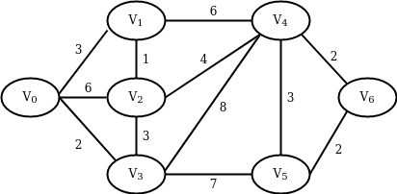

3 a) Show that the hypotheses, “if you send me an email message, then I will finish writing the program”. “If you do not send me an email message, then I will go to sleep early”, and “if I go to sleep early, then I will wake up feeling refreshed” lead to the conclusion “If I do not finish writing the program, then I will wake up feeling refreshed.” using rules if inferences.

4 a) Derive the characteristics equation for a linear homogeneous recurrence relation.
4 b) Using mathematical induction, prove that 1+2 …. + n = n(n+1)/2, where n is a positive integer.
6 a) Explain the concept Finite State Machine with an example.
6 b) Construct a DFA with transition table as well as transition diagram that accepts the multiple of 3.
7. Write shorts notes on any two:
a) Graph coloring
b) Regular Expression
c) Quantification

